Work Instructions for Human Safety
Scope: All over the plant.

Ref: Nil

- Aspect: Waste generation and dust spreading
- Impact: Resource depletion and air pollution
- Hazards: smoke, Impact due Improper design tools, Electric shock

- Breakdowns on luminaries should not be attended at site. All repairs shall be carried out at workshop only. It shall be ensured that the lamp replacement is carried out only after putting off the supply. Use LOTO on MCB or feeder while attending any luminaries at site.
Responsibility: Electrician

- Halogen lamp fittings shall not be used as portable fitting. For any temporary illumination
halogen fitting shall be properly secured near the workplace using halogen stand as per requirement of user.
Responsibility: User

- For portable lighting 24V hand lamp should be used. Power supply to hand lamp should be through 30mA ELCB. Responsibility: Electrician & User

- It shall be ensured that all portable equipment and welding machines shall have supply cable in one single length. Use of jointed cables is prohibited.
Responsibility: User and welder in case of welding Machines

- Supply to all portable equipment shall be given only through a socket having ELCB protection. Wherever ELCB provisions are not there, one can use portable extension board having ELCB, available at tool room. ELCB rating shall be 30mA.
Responsibility: Electrician and concerned User

- Before giving supply, insulation value of equipment should be checked.. Do not give supply to equipment whose insulation value is poor i.e.below 1000 Kohm..
Responsibility: Electrician

- It shall be ensured that all third party/ contractor related jobs are carried out under the close
supervision of engineer concerned of that area. In absence of area engineer, engineer authorising the protocol/ electrical shutdown shall ensure the supervision
Responsibility: Engineer and contractor supervisor

- While shifting ladder, due care must be taken to ensure that ladder doesn’t touch Electrical overhead line. If required Ladder should be shifted horizontally. Taking and using the ladder inside 33 kV substation will be permitted only with permissions/ supervisions of Engineer incharge.
Responsibility: Engineer and contractor supervisor

- While working on overhead line/ panel busbar system (during APM/ breakdowns/ modifications) ensure to short all the 3 phases, neutral to Earth by using shorting links.
Responsibility: Electrician and Engineer

- Nobody should try to check the supply on HT system directly by any tools
Responsibility: Electrician and Engineer

- Portable light fitting which is operated on 230V supply shall not be used inside the closed vessel/ silo’s. Only 24 V handlamps are allowed.
Responsibility: Electrician and Engineer

- Do not use compressed air for cleaning over body.
Responsibility: Electrician and Engineer

- Use of life jacket is a must while working at napolim pantoon and at bandhara pumping station hoist located above bandhara gates. Life jackets are made available at the respective location of the pumping station in the custody of security.

- Before entering gas prone area such as Ventury pump & Ventury Drive (GCS area), Hot blast stoves, thickener area(slag granulation panel room, Pcm recirculation panel , GCS panel room,
4T slag grab crane and 4T iron ore Grab crane ) Dust catcher , Top charging power pack, Hearth Area, Control room Enginner to be informed and min two persons should enter the area with 2 nos CO monitors.
15. No power Circuit to be kept remain charged with faulty RCCB . In no case RCCB can be bypassed.
16. Temporary electrical installation to be provided with dust & rain protection. Temporary connections to be disconnected immediately after the use after intimation from user. Temporary abandoned power sockets to be checked thoroughly for insulation resistance before usage. Ensure proper earthing is provided prior to energizing the temporary electrical installation.
Responsibility: Engineer and contractor supervisor

17. Use a standard rescue hook which is made available in the panel rooms for pulling the person who has fallen unconscious on the live bus bar system due to electrocution

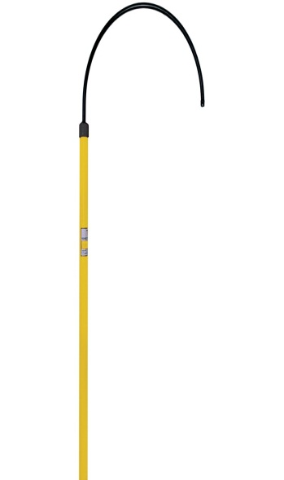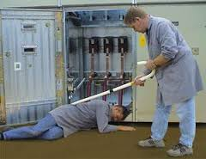

Amendement Record
Date | Manual Section Ref. & Para | Brief details of Revision | New Rev.

Prepared By:  Senior Elect. Engineer | Reviewed & Issued By:  Management Representative | Approved By:  Head – Electrical & Instrumentation PID I
Signature | Signature: | Signature:
Review Date: 04.03.2023 | Review Date: 04.03.2023 | Review Date: 04.03.2023

